EXPERIMENT NO : 2
Serving Cell Along the Mobil
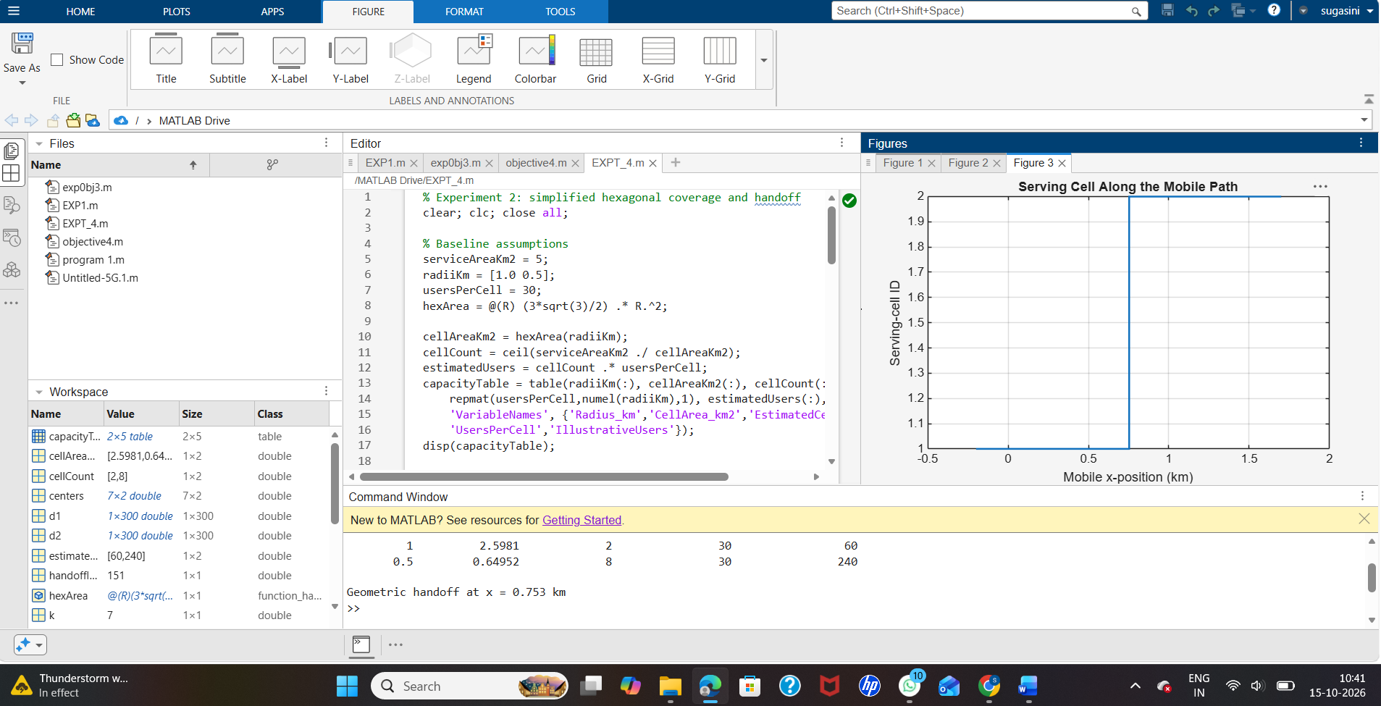
Nearest-Center Handoff Approximation
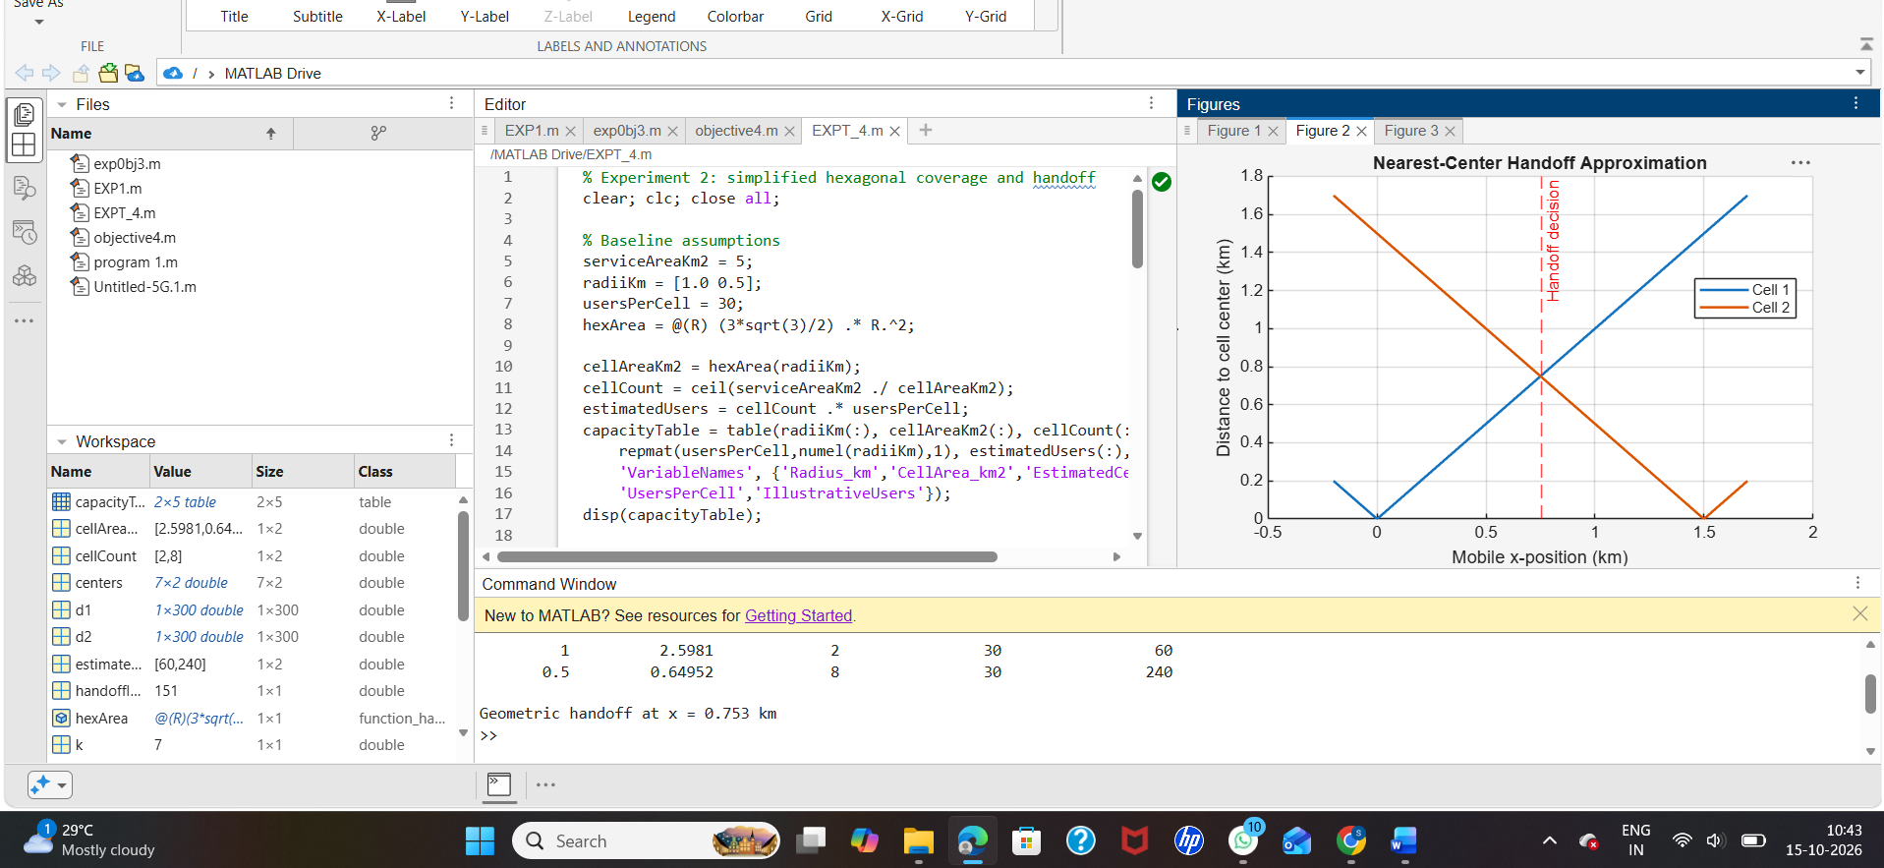
Idealized Seven-Cell Hexagonal Cluster
